Project Design Phase Proposed Solution Template

Date | 12/09/2026
Student Name | Navya Sri Tangellamudi
Project Name | Intergalactic Space Travel Request System (ISTR)
Maximum Marks | 2 Marks

Solution Overview:
Approving an interplanetary mission today means routing a request through a chain of emails, spreadsheets, and phone calls across a Requester, Manager, Finance Officer, and Mission Control — with no shared record of where it stands. As mission volume grows across agencies and destinations, this manual chain breaks down: approvals stall past their real deadlines, risk review depends on who happens to notice a request rather than a consistent rule, and there is no single trail an auditor or regulator can review after the fact.
ISTR closes that gap with a ServiceNow scoped application: one custom table holds every mission request, Flow Designer enforces who must approve it and in what order, and SLA timers turn silent delays into visible escalations. The design is intentionally narrow in scope for v1.0 — approval routing, RBAC, and audit — so it can be built, tested, and demonstrated within the project timeline, while the modular table/flow structure leaves room to add mission types, risk tiers, or approver roles later without a redesign.

Solution Flow — At a Glance:
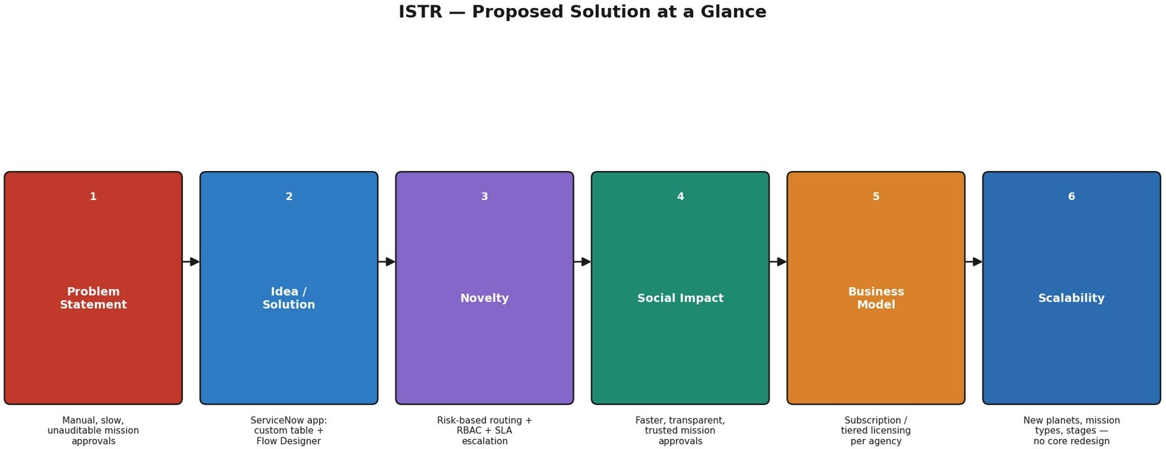

Detailed Description:

S.No. | Parameter | Description
1. | Problem Statement | - Mission travel requests are approved via manual, paper- or email-based chains across Requesters, Managers, Finance, and Mission Control.  - No enforced SLA means approvals stall for days with no escalation trigger.  - Risk review is inconsistent — a High-risk mission can slip through with the same scrutiny as a routine one.  - No centralized audit trail, so post-mission compliance review is slow and error-prone.
2. | Idea / Solution | - ServiceNow scoped app on a custom table (u_space_travel_request) with Flow Designer orchestration.  - Conditional routing: Manager → Finance → Mission Control (only for High/Critical risk) → Admin Launch.  - Role-based UI, dashboards, and notifications so each stakeholder only sees and acts on what's relevant to them.
3. | Novelty / Uniqueness | - Risk-based conditional escalation, not a flat approval chain — Mission Control only engages when risk justifies it.  - SLA timers paired with automatic escalation, not just passive status fields.  - Purpose-built data model for interplanetary mission governance, versus a generic ticket or spreadsheet repurposed for the job.
4. | Social Impact / Customer Satisfaction | - Cuts approval turnaround from days to hours by removing manual chasing.  - Gives every stakeholder real-time visibility, reducing anxiety and repeated status-check emails.  - Builds trust through a tamper-evident audit trail and consistent rule enforcement across all missions and agencies.
5. | Business Model (Revenue Model) | - ServiceNow app/subscription licensed to space agencies and interplanetary mission operators.  - Tiered pricing by active missions and user-role seats (Requester/Manager/Finance/Mission Control/Admin).  - Add-on revenue: advanced analytics, external mission-control integrations, multi-agency approval support.

S.No. | Parameter | Description
6. | Scalability of the Solution | - Modular custom table + Flow Designer design absorbs new planets, mission types, and approval stages without core redesign.  - Update Sets give clean Dev → Test → Prod migration as the agency's footprint grows.  - Architecture supports scaling from a single agency to a multi-agency, cross-jurisdiction operation.

How ISTR Compares:

Evaluation Criteria | Manual / Email Process | Generic Ticketing Tool | ISTR (Proposed)
Approval turnaround | Days, no visibility | Hours to a day, generic queue | Hours, risk-routed and SLA-timed
Risk-based escalation | None — manual judgment | Not built in | Automatic, conditional on risk level
Auditability | Scattered emails/paper | Basic ticket history | Full state-change audit trail
Role-based access | Informal, trust-based | Generic permission sets | Fine-grained ACLs per stakeholder

Target Beneficiaries / Market Segment:
The immediate target is a single interplanetary space agency's mission operations division — Requesters (mission scientists/explorers), their Managers, Finance Officers, and Mission Control reviewers. As adoption proves out, the natural expansion path is to allied agencies running joint missions, where a shared, auditable approval standard becomes even more valuable across organizational boundaries.

Stakeholder Benefits:

Stakeholder | Pain Today | Benefit with ISTR
Requester (Explorer) | No visibility into where a request sits; repeated status-check emails. | Real-time status on a personal dashboard; confirmation and update notifications.
Manager | Approval requests buried in inbox with no reminder if missed. | Dedicated approval queue with SLA reminders before breach.
Finance Officer | Budget figures scattered across emails/spreadsheets, hard to reconcile. | Structured cost field on every request, editable only by Finance, fully logged.
Mission Control | No consistent trigger for when a mission needs their review. | Automatic routing only for High/Critical risk missions — no noise, no missed cases.
Admin | Launch decisions made informally with no single source of truth. | Launch action gated on system state; one-click trigger with full audit trail.

SWOT Analysis:

Strengths | Weaknesses
- Native ServiceNow build — no new infrastructure to procure or maintain.  - Risk-based routing reduces unnecessary approval steps for low-risk missions.  - Modular design supports rapid expansion to new mission types. | - v1.0 scope excludes advanced analytics and external mission-control integration.  - Depends on accurate risk classification at submission — a mis-tagged request could under-route.
Opportunities | Threats
- Expand to multi-agency approval support as adoption grows.  - Add predictive risk-scoring using Predictive Intelligence in a later release.  - License to allied agencies once proven on a home instance. | - Competing generic ITSM/ticketing tools already in use at some agencies may resist replacement.  - Regulatory changes across agencies could require frequent approval-rule updates.

Implementation Roadmap:

Phase | Focus | Key Deliverable
Phase 1 | Data model & security | Custom table, roles, groups, and ACLs defined and tested
Phase 2 | Approval automation | Flow Designer routing (Manager → Finance → Mission Control) live end to end
Phase 3 | SLA & notifications | SLA definitions, escalation flows, and email notifications configured
Phase 4 | UI & dashboards | Service Portal request form, role-specific dashboards, and UI actions (Launch)
Phase 5 | Testing & rollout | Functional/UAT testing complete, Update Set migrated Dev → Test → Prod

Key Success Metrics (KPIs):
- Average mission-request approval time (target: under 24 hours for standard risk, under 48 hours for High/Critical).
- Percentage of approvals completed within SLA (target: 95%+).
- Audit completeness — percentage of state changes with a full logged trail (target: 100%).
- Requester satisfaction with status visibility, measured via post-mission survey.
- Reduction in duplicate status-check emails/messages compared to the pre-ISTR baseline.

Feasibility & Key Risks:
- Feasibility: builds entirely on native ServiceNow capabilities (custom tables, Flow Designer, ACLs) — no unsupported third-party dependency for v1.0.
- Risk — role misconfiguration exposing sensitive mission data: mitigated by least-privilege ACLs and role-based testing before go-live.
- Risk — SLA definitions too rigid for edge-case missions: mitigated by configurable SLA schedules per mission type rather than a single hard-coded timer.
- Risk — inaccurate risk classification at submission under-routing a high-risk mission: mitigated by mandatory risk-level field validation and periodic Mission Control spot-checks.

